Dandenong Ranges Steiner School warmly invites you to attend one of our upcoming Tours 2020.
Tuesday July 20th
Tuesday August 17th Tuesday Sept. 7th
Sunday October 24th
(Spring Fair & Market Day - open classrooms)
Tuesday Nov. 9th
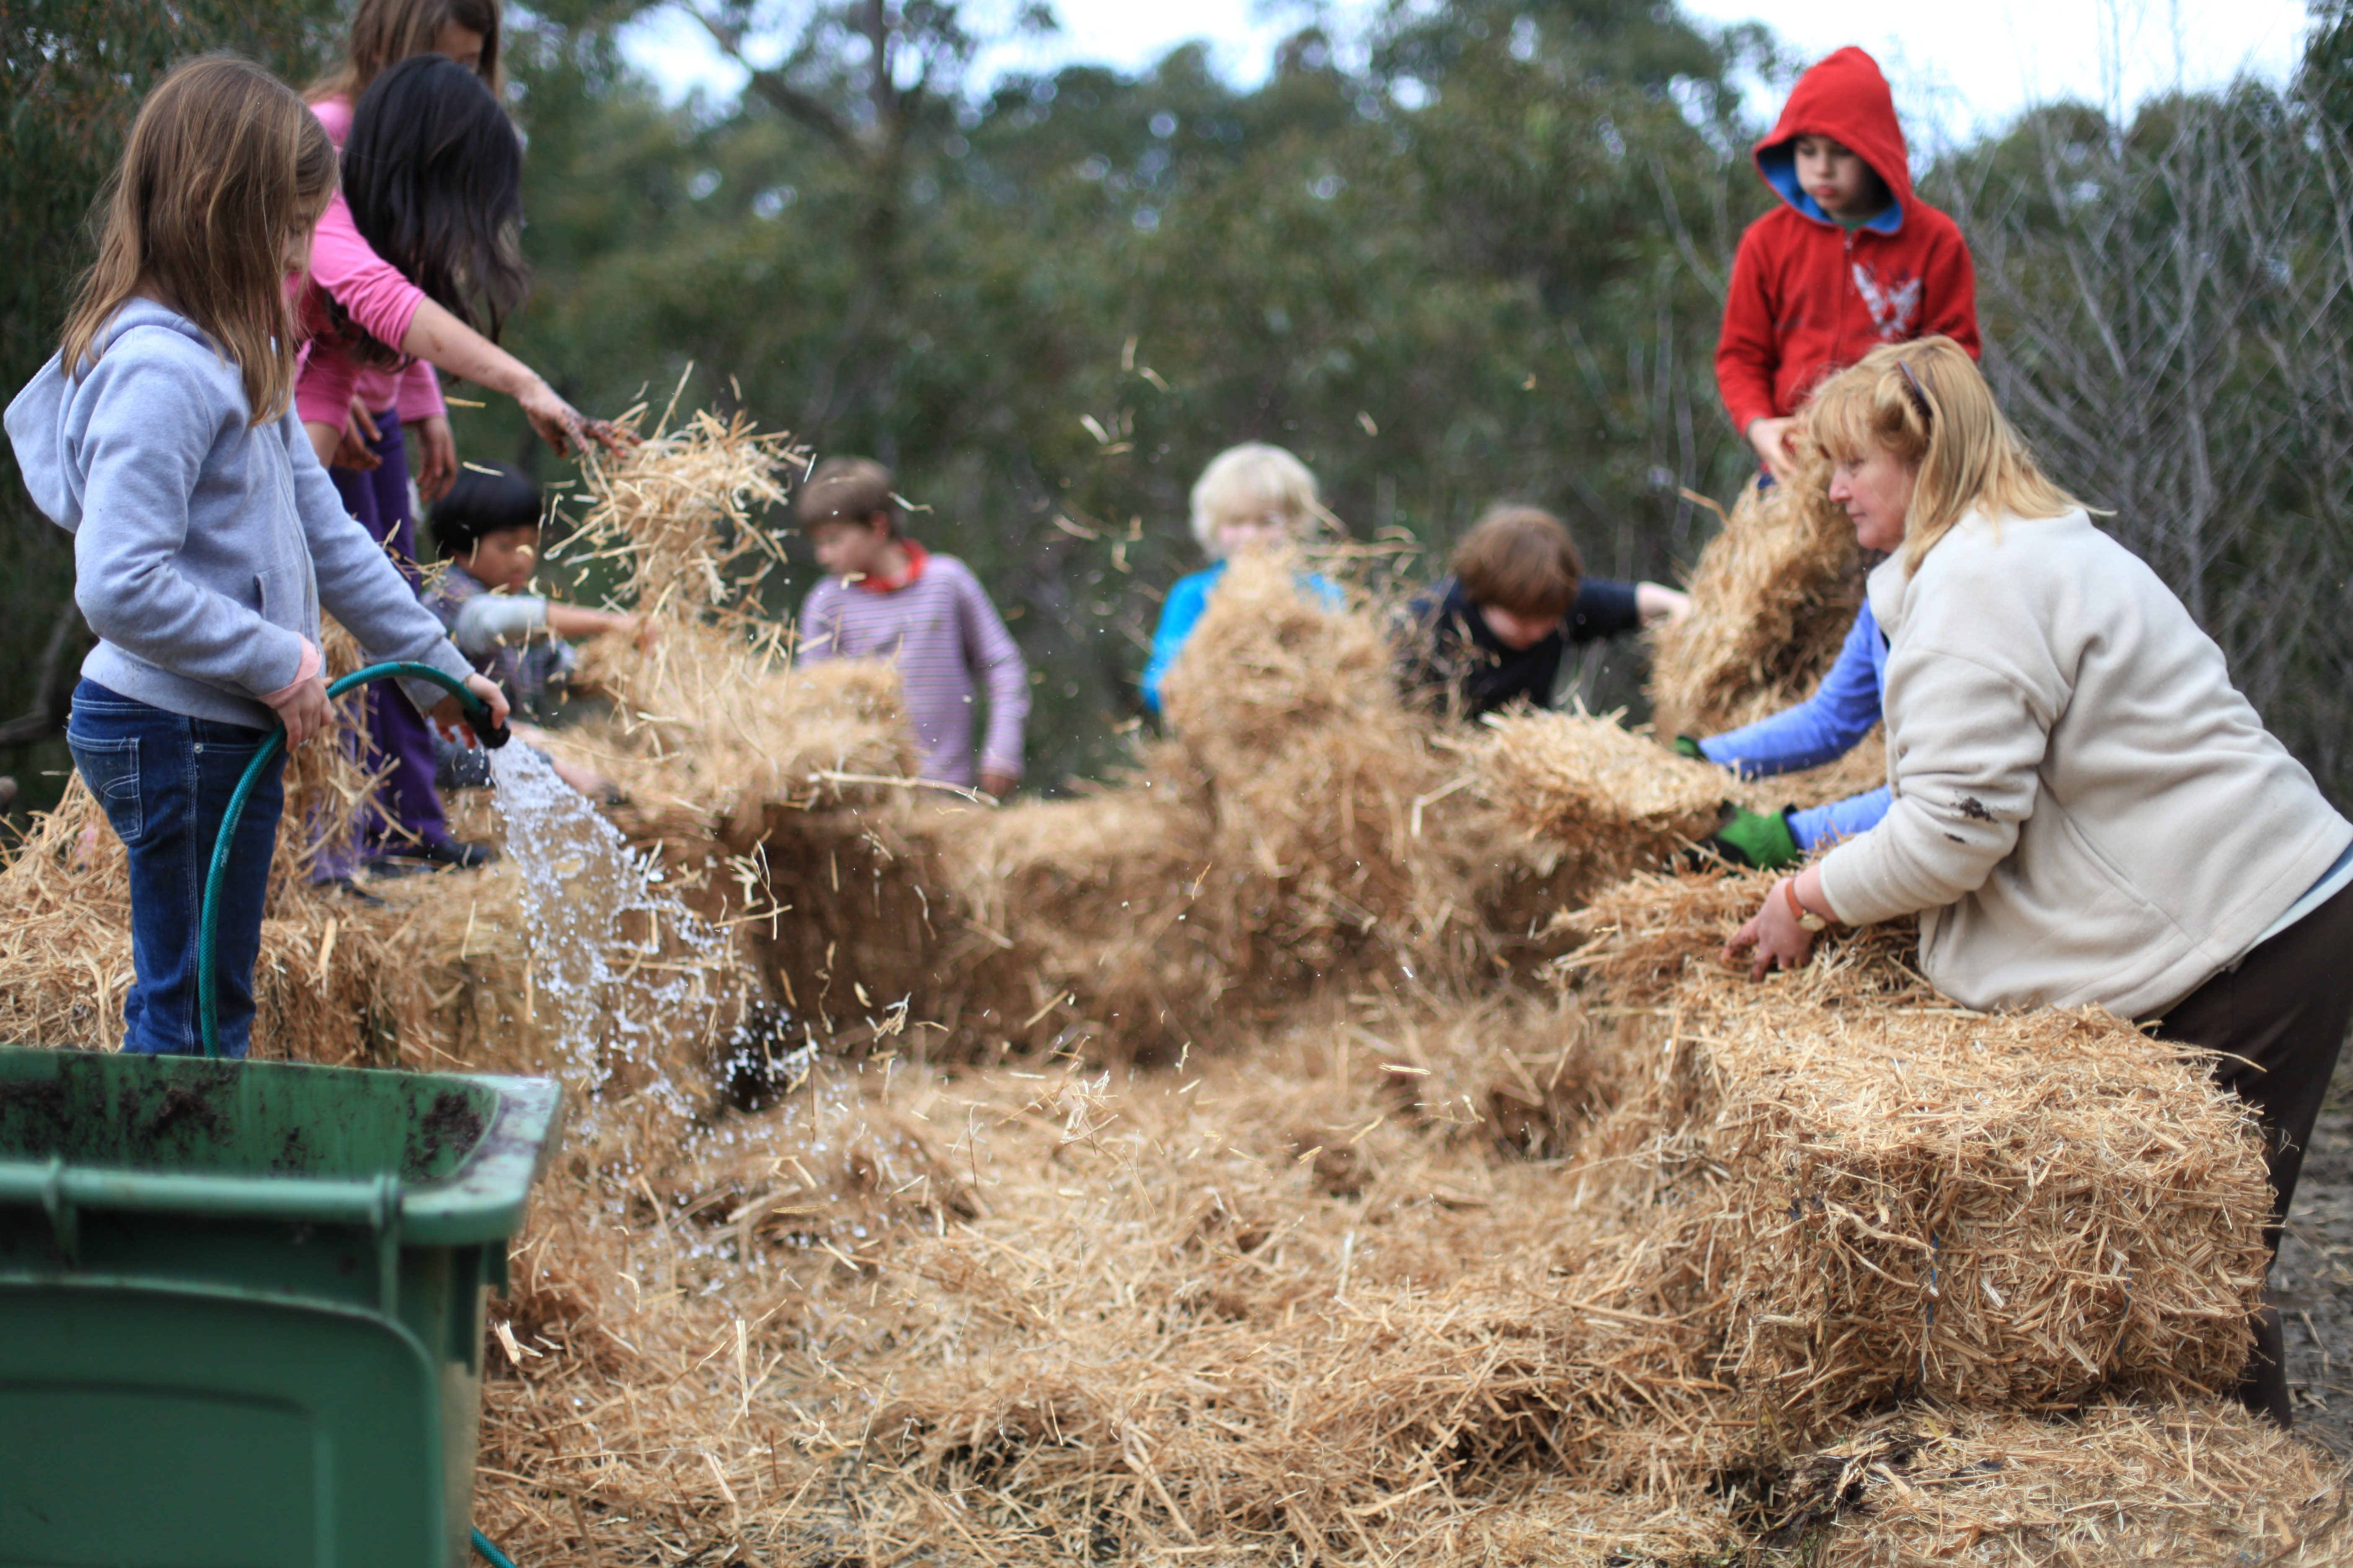
Tuesday December 7th
Tours begin promptly at 9:15 at the Early Childhood Campus located at 51 School Road, Menzies Creek. The tour continues at the Primary Campus at 10:00 located just down the road at 11c Duffys Road, Emerald.

Followed by an Information
Session and Morning Tea.

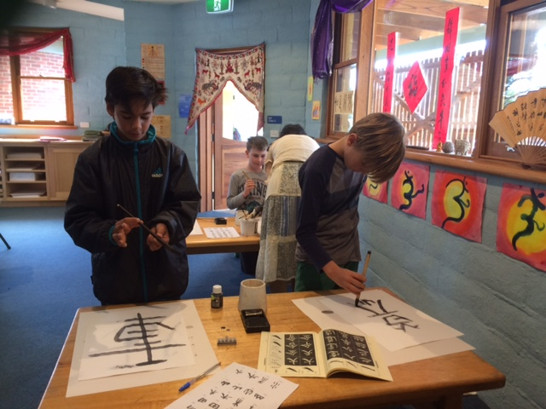
For more information or to book into one of our tours please contact Karen Frazier Walsh on 8790 4797 or email: enquiries@drss.vic.edu.au

