Dandenong Ranges Steiner School warmly invites you to attend one of our upcoming Tours 2021.
Tuesday February 16th Tuesday March 16th
Tuesday April 27th
Saturday May 15th (Early Childhood Open Day) Thursday May 20th (Primary School Open Day)
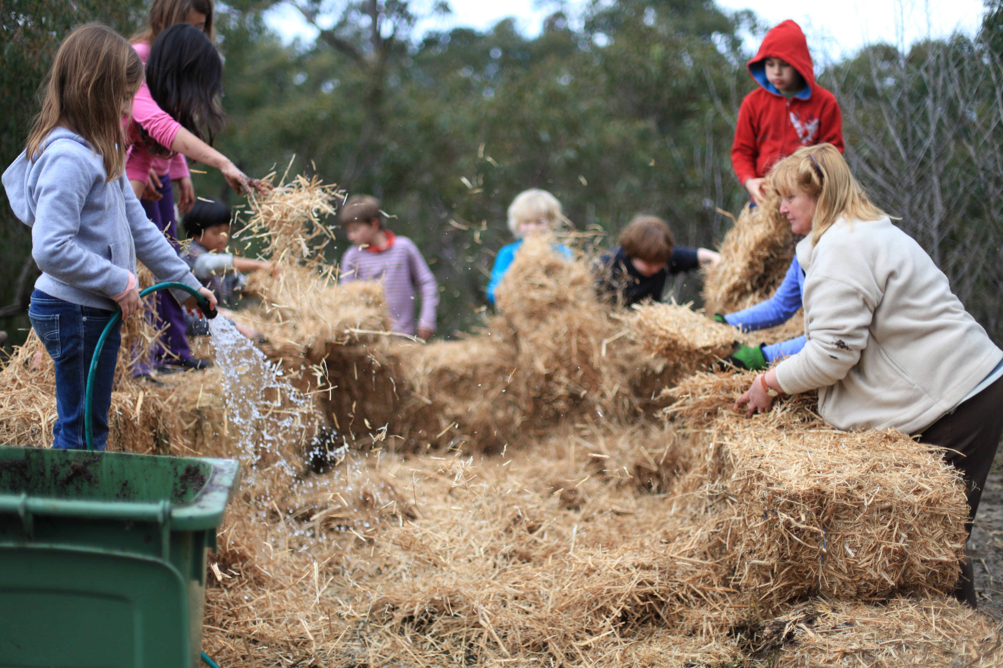
Tuesday June 15th
All tours begin promptly at 9:15 at the Early Childhood Campus located at 51 School Road, Menzies Creek. The tour continues at the Primary Campus at 10:00 located just down the road at 11c Duffys Road, Emerald.

Followed by an Information Session and Morning Tea.

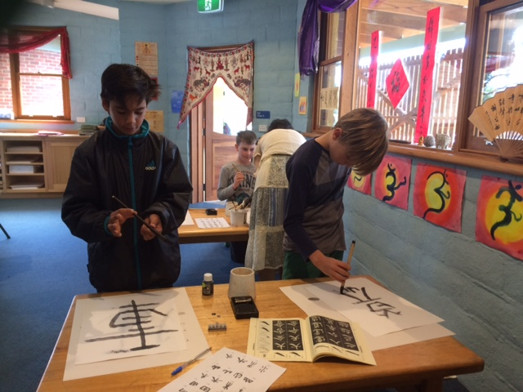

To book into one of our tours please contact Karen Frazier Walsh on 8790 4797 or email: enquiries@drss.vic.edu.au

